VGA Image Generation using FastLCD
Tool used : FastLCD. 
Text editor : notepad, wordpad or Notepad++ .

Resize your image to 400x200 (with PAINT or other WIN tool ), invert colors if needed and save it in BMP format.

First use this tool 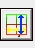 to set LCD size to 400 x 200 .

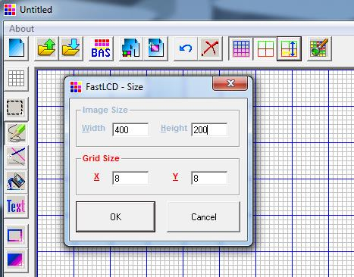

Open the saved BMP file and past it.

You can use the arrows in top right to move the image or to mirror it.

or You can draw image manually with tools like :Text, symbols …. On the left of the window to draw an image. Left Clic sets the pixel and right clic resets (clears) it.
Save the image in BMP format.  then shut FastLCD and restart it again. open the saved image Then click “BAS” to generate BAS file (actually this program is used to generate BASIC file, but we will see how to do a trick to make it C file ). Choose T6963C, font select pin 0 (8bits, font8x8) and don’t forget to save as “Image”.
NOTE: in WIN7 I could not save the file as BMP, so generate BAS without saving !!

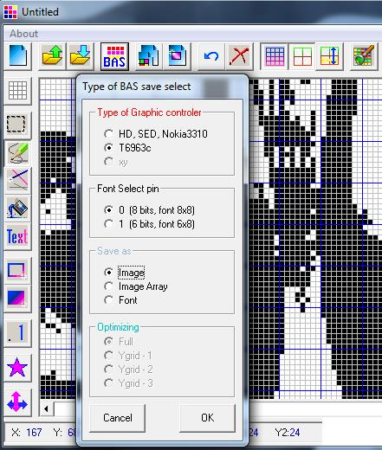

Open the generated *.BAS file using your favorite text editor.
Remove 1st line and the 2nd line then select replace menu from your text editor and replace &h with 0x

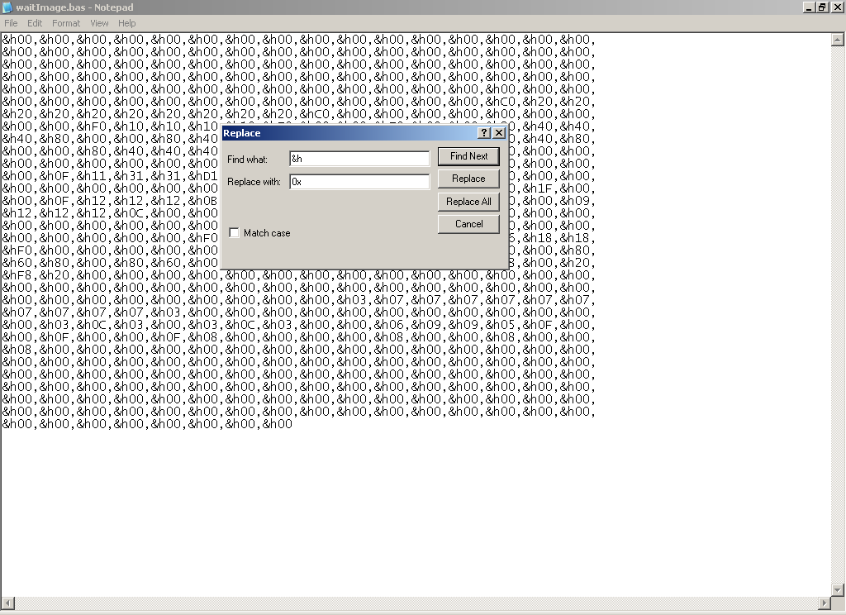

Last, add the name of the image “ const unsigned char img[] = { “ in the beginning of file; and add “ }; “ in the end.

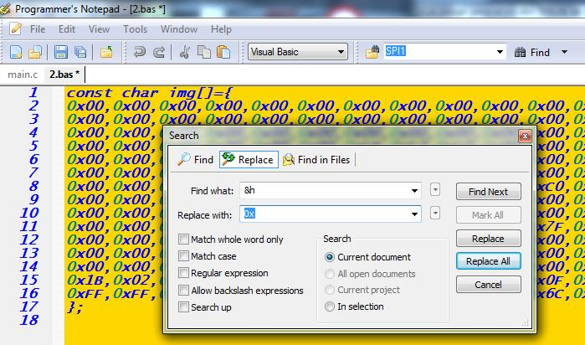

Save the file as “image.h” , you can now add it to your project .

